Expert Systems

Comparing various algorithms
Following flow diagrams depict various algorithms which we have tried and you would find the quantitative and qualitative analysis of the performance of various algorithms in following sections.

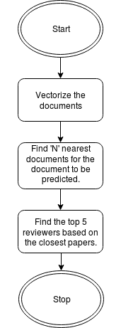
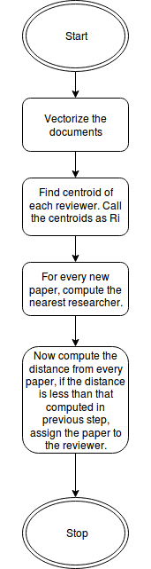
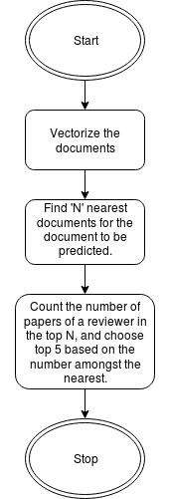
Algorithm 1:
Algo 1
Algo 3
Algo 2
This algorithm takes into account the papers that are the nearest to the given paper. It selects the reviewers who have written and published similar papers in past. A drawback of this algorithm is that it doesn’t take into considerations the number of papers a reviewer has written which are similar to the paper to be reviewed. Algorithm 3 cleverly deals with this issue.

Algorithm 2:
This algorithm is computationally very intensive. Despite of being computationally intensive, the results, are expected to be highly inaccurate. Firstly the algorithms needs to find centroids of reviewers. Logically, the term centroid of a reviewer has no physical significance. This term eliminates the possibility that a reviewer might have multiple fields of interest. The algorithm, as expected, takes a lot of time to evaluate the output, because of distance calculations from every paper in the training set.

Algorithm 3:
This algorithm not only acknowledges the papers which are close to a given paper, but also consider the number of papers a particular reviewer has in the vicinity of the paper. This, I think could give us the best possible reviewers for a particular paper.

Quantitative analysis
We have implemented Algorithm 1, 2 and 3. Our implementation of algorithm 2 was without library functions from sk-learn, so the computations were quite inefficient. A comparision of quantitative parameters for the same with other 2 would be inappropriate. The other 2, namely 1 and 3 are quantified as below.
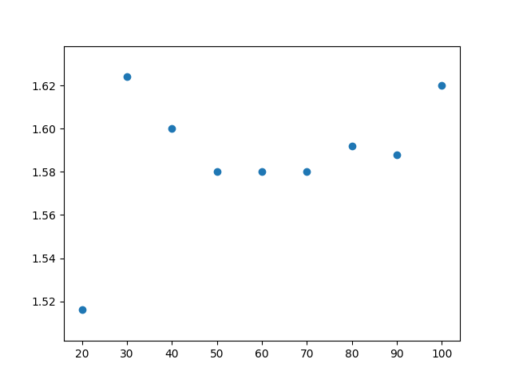
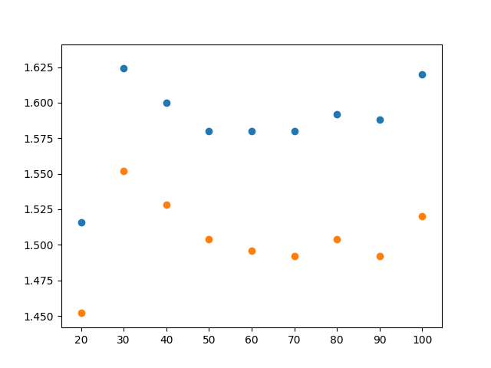
The blue dots correspond to algorithm 3, the orange dots correspond to algorithm 1. As is evident from the steps involved, 3 is a mere extension of 1 and it takes an offset amount of time more than algoritm 1.
Time
As could be seen from the graph, the time required is the minimum in the range of N in 50 – 70. Increasing the value of N only adds up to the time required to compute number of instances of a particular author. It in fact reduces the idea of vivinity from the paper.
In conclusion, increasing the value of N not only decreases the efficiency, but also affects the accuracy.
N --->

